The Florida Water Story Application

Abstract:

The main contributors to the development of this application were Alyssa Guarinello, Miley Simpkin, Trent Lien, and Toni-Ann Peck. Within these three weeks, we’ve developed an application that introduces users to the history and movement of Florida’s water. It is marketed towards young teens and older children: between the age groups of 8-13. The application, Florida Water Story, is named after the exhibit of the same name in the Museum of Discovery and Science. The Museum, also known as MODS, commissioned this team to build and maintain this app.

Background:

Before even forming groups, we met at MODS, learning about the museum and its exhibits. Later, as summer approached, we split into groups and learned about a single portion of the museum. When the FAU classes finally began, the group was together, planning the layout and code together as part of the mockup. Everything in these meetings was conceptual- simple ideas for the design and basis of the app. Most of these concepts had been discussed at the museum before. The app’s development began with layout design; the group members of the Florida Water Story app conversed constantly with the UI team, determining what images and design schemes worked best with Android Studio. Java coding was largely dormant during this time, as the app had to be planned out in detail before it could be implemented into the program. Scripts were developed and ideas logged as to how the program could be coded smoothly.

Methods:

As the project manager, Toni-Ann tried to organize and assemble our group to finalize the app and keep the information and assignments up to date. Even so, it was the efforts of the entire group that made this app possible. It was especially imperative that they worked together on this endeavor, as no one person could have completed this app in such little time on their own. The graphics and programming teams were always constantly at work, simultaneously learning new techniques to performing their job and supplementing the other team’s progress. As a graphics team member, Toni-Ann didn’t think she’d have to learn too much about the coding side, since the pictures that we developed would be imported straight into the app, however sizing, color, and shape were all very important aspects of the graphics that we had to discuss with the programming group members.

After the first day of class, the graphics teams of each app group were separated from their coding groups to help each group learn the capabilities and functionalities of each position. While the graphics side learned to use Adobe Illustrator and Photoshop, the programming side learned the functions of Android Studio and Java. By the second class day, real progress was already made in the development of the app: Toni-Ann, as part of the graphics team, had begun making designs with Trent, the other graphics member. The graphics stayed close to the balsamiq mockups, using many of the same design schemes but increasing their complexity for more aesthetic appeal and finding colors that better complimented each other. By the end of the first week, a slew of designs had been submitted to the group’s Google Drive and Github repositories.

Graphics from the Github repository:

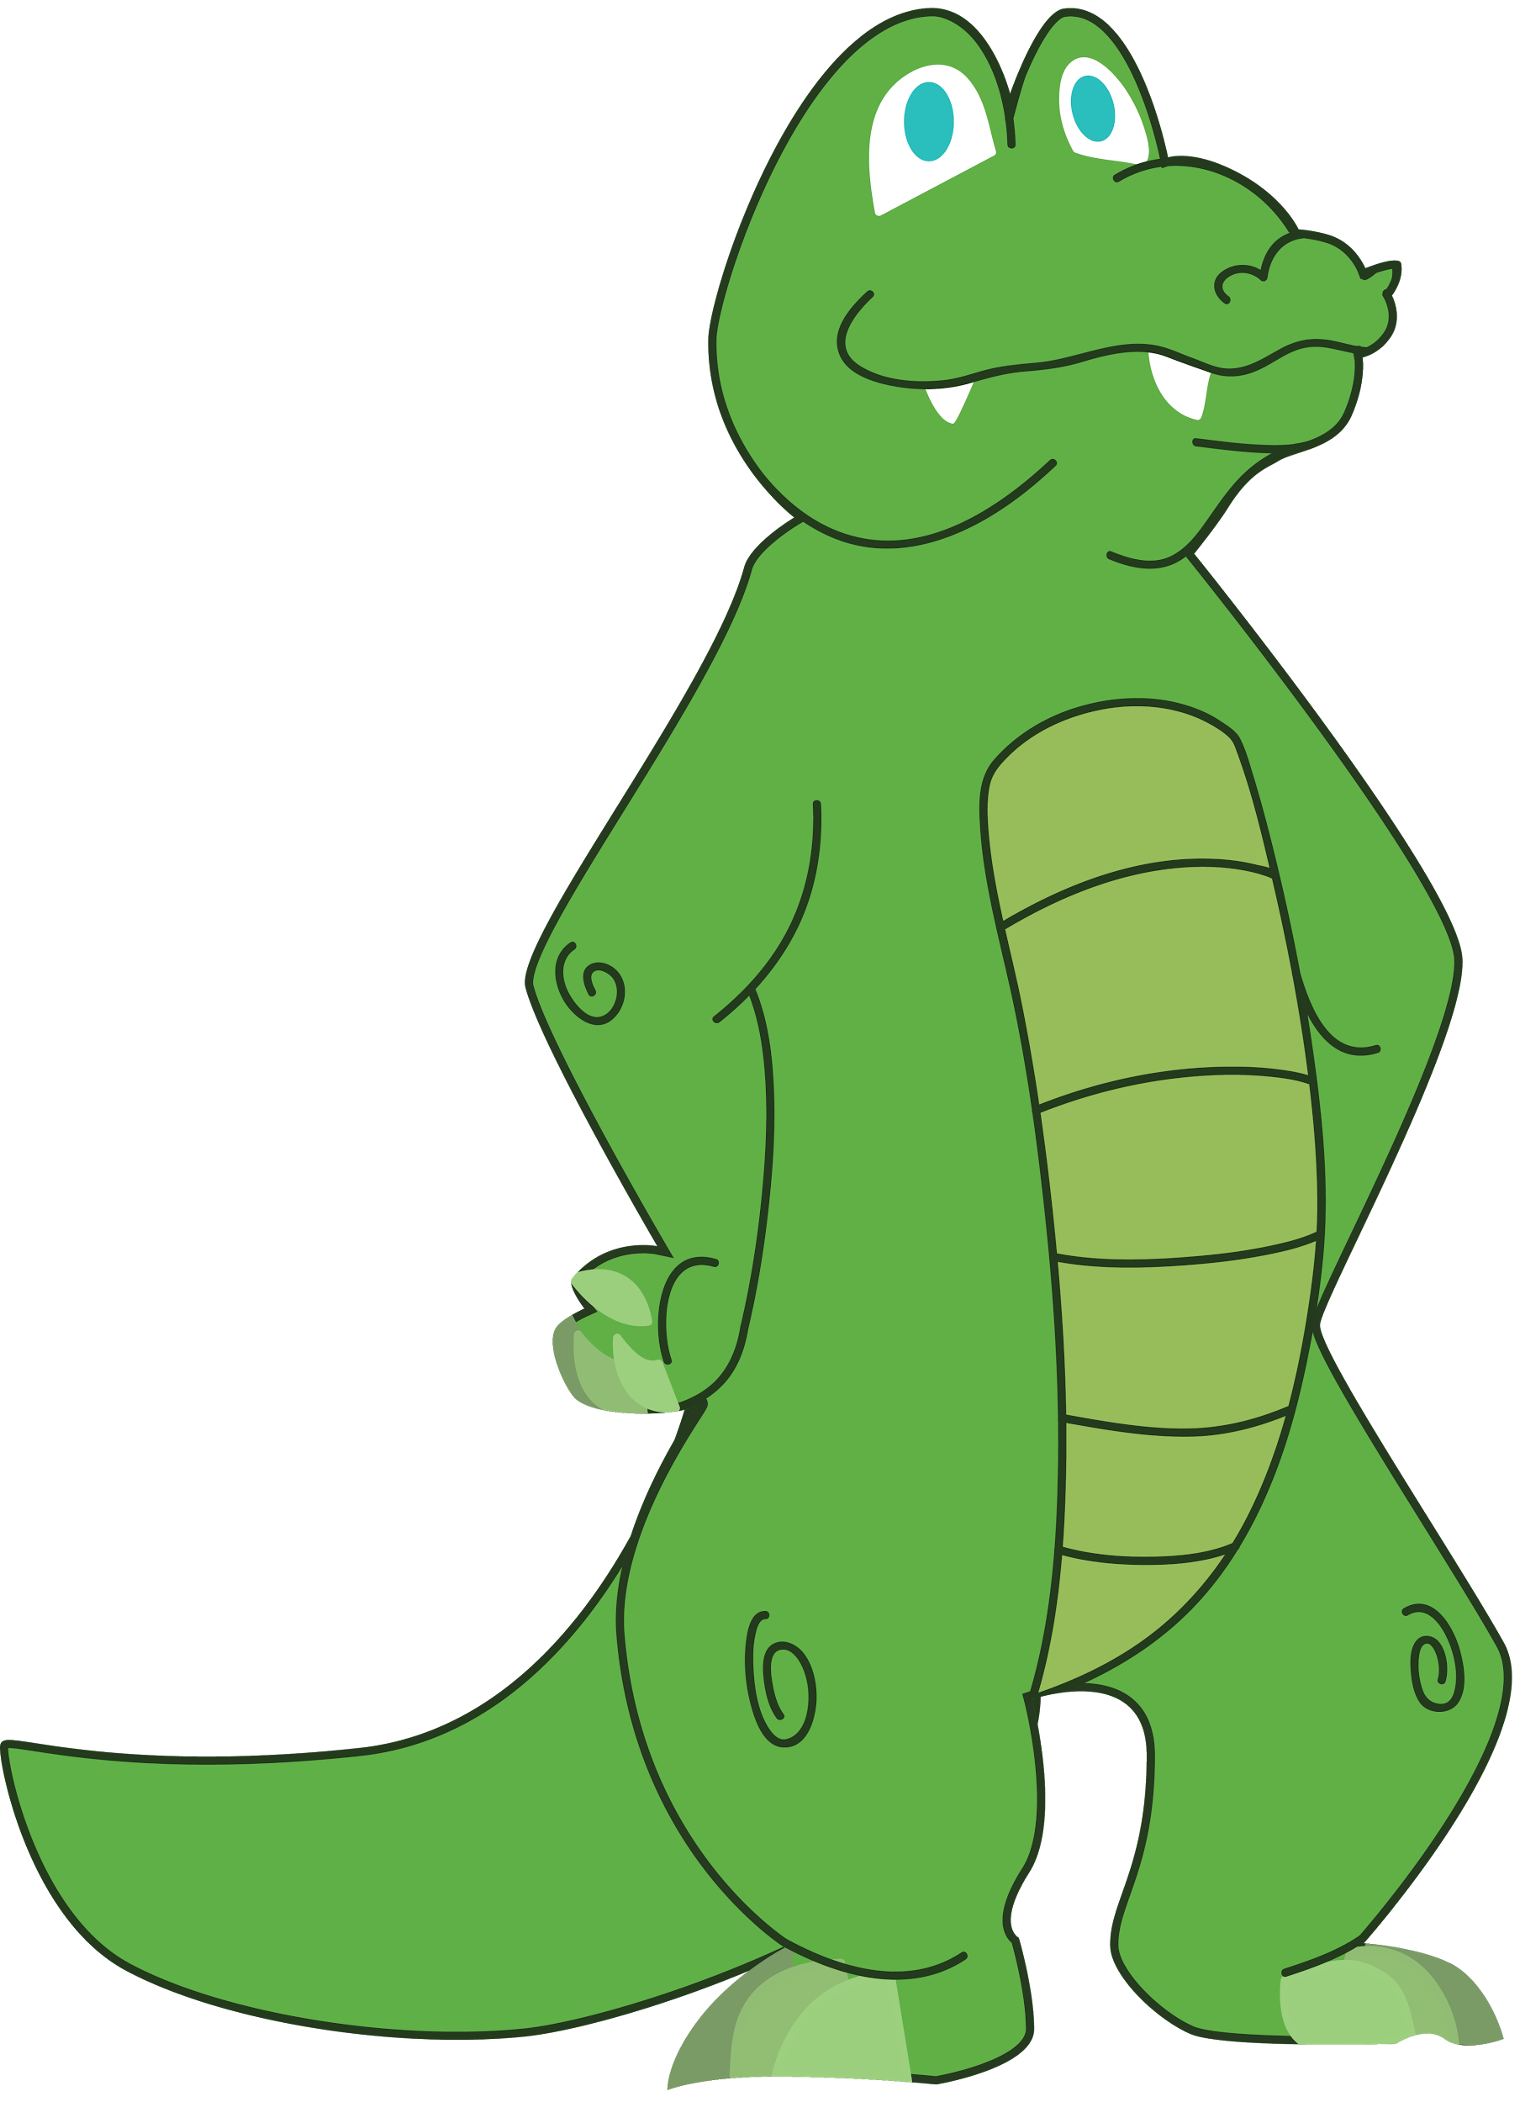 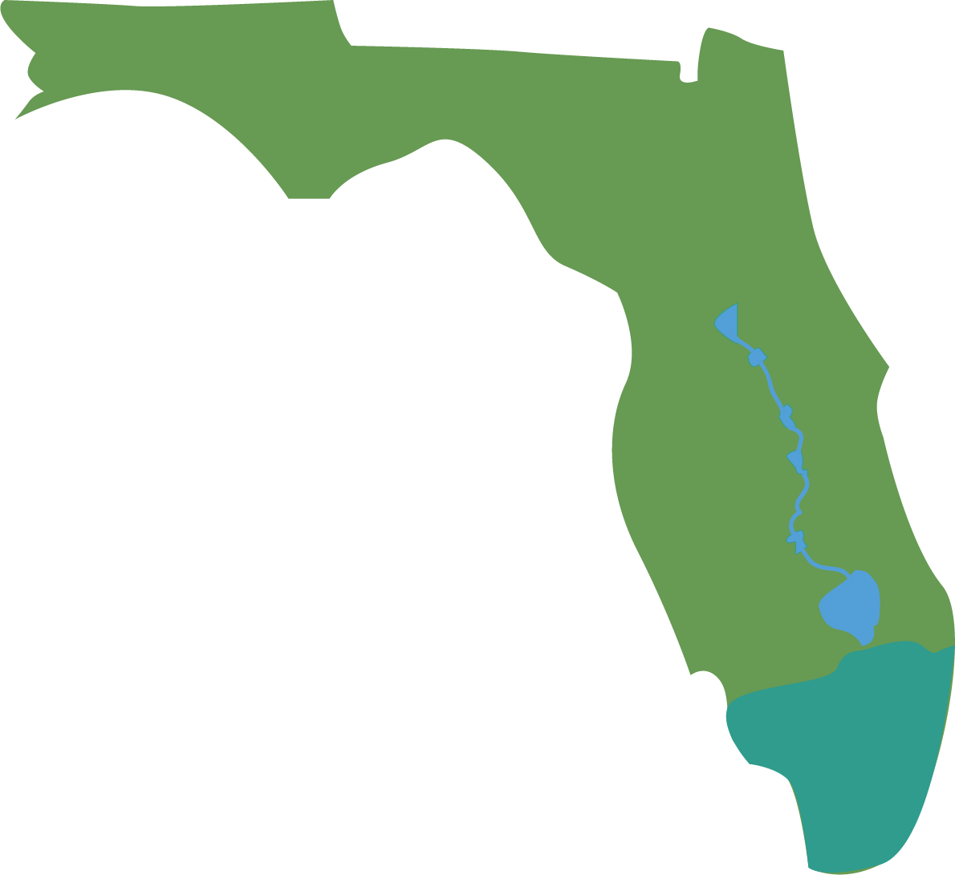

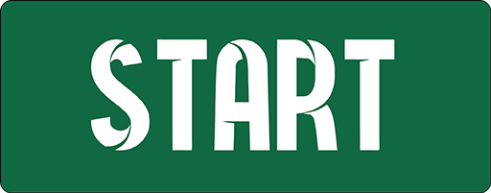 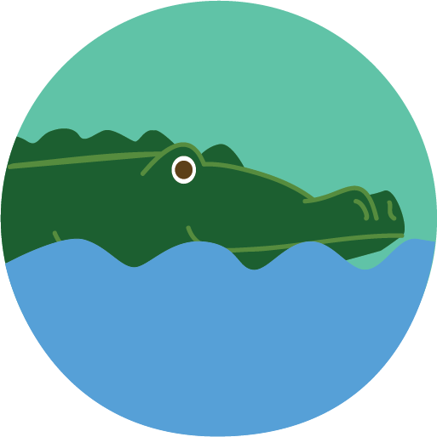

App development continued, and the goal of the app changed some. Instead of having it centered around a game, as was originally intended, the application became more story based. This change was especially caused by the suggestions of Joe Cytaki, the Vice President of Programs at the Museum of Discovery and Science. The graphics thus changed to suit new activities and a scrolling UI. Augmented reality was also an idea that was dropped, as the graphics team had a large amount of 2D art that needed to be produced. There was no time to produce and animate a model while drawing the cartoon that would delineate the story for users of the mobile application. Trent, who was initially given the task of AR development, instead helped Toni-Ann work on buttons and icons for the UI designer to implement.

Alyssa Guarinello worked as the UI designer for the app. As she began the APPtitude internship at MODS and completing her initial classes at FAU, Alyssa had no prior experience with Java or coding in general. At FAU, she got to learn firsthand how to code in Android Studio, troubleshoot, and create an appealing and functioning application. Thanks to the professors and teacher’s assistants, she was able to increase her knowledge enormously in the fields of coding and Android Studio.

Although Alyssa had no prior experience with coding, she quickly learned how to structure activities and design basic .xml pages. Once she learned the basics of user interface, the daunting task of creating a fully-functioning application soon transformed into a fun challenge. She was primarily taught by Doctor Shankar and Santiago, who helped her understand how to code buttons and link them to other activities. After learning how to make buttons access other activities, the rest of my work was simply designing the button’s placements and the aesthetic of the .xml pages. She was in charge of taking the creations from graphics for the cartoon comics and putting them into scroll views in the application. Before we even started coding, our team brainstormed ideas on what we wanted the basic layout of the app to look like. We used Balsamiq mockups to mirror our creative ideas and how we wanted the app to be laid out. The first mockup included Google Analytics, such as taking the user’s name and age, but we eventually decided it would be more time effective and user-friendly to incorporate a Google Maps activity instead. Although this concept changed from our mockup to the final app design, the rest of the mockup stayed relatively similar. We used a GitHub repository to share files easily with team members as well as FAU staff. The structure Doctor Shankar advised the groups to use made accessing all of the group and project assignments very simple. We also used GitHub to submit assignment links to Blackboard, so Doctor Shankar could easily access our structured “tree” of assignments.

The first assignment, to test the programming team’s ability to wield Android Studio, was to load the previous group’s code onto the programming platform. This not only allowed the teams to become used to the language, but also allowed them to inspect the previous year’s code and decide whether or not they wanted to use it. Teams learned how to edit code uploaded through Github and how to make updates on code while keeping records of working code.

Screenshots of Project and Group Assignments from the Github repository:

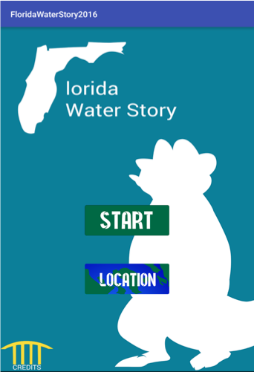 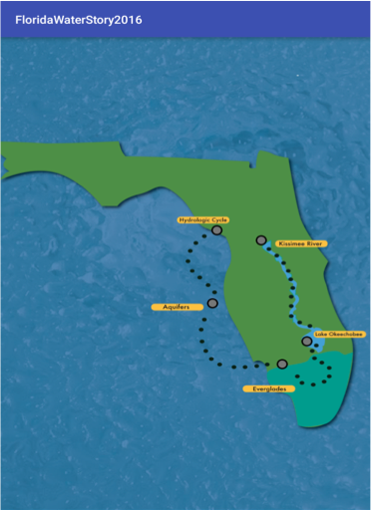

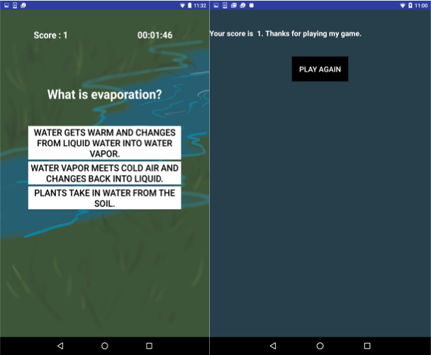

The app’s game was brainstormed and planned out for longer than any other one of its components. Miley Simpkin handled this portion of the app as the Java programmer for the team. The initial game design proved too extensive to code in the short time we’d had to work in, so the game idea changed from a complicated one to a quiz game. The bulk of this part of the app was created near the end of the program, in its last week, after Miley had learned all she needed to properly make the app.

Results:

When the application was completely finished, we were advised to make a short “promotional” video, showing off key features of the app and how it works. The video we made for our app included showing the Google Maps feature, the treasure map layout of our home screen, the cartoon slides for each of our five main activities, and the timed trivia game. The video shows how to navigate the app and how to reset the colored map buttons that change to “completed” when clicked on. When we showed the guests from the Museum of Discovery and Science, they seemed to understand how the application worked. The video was integrated into our PowerPoint, which also highlighted the app’s main features in more detail.

Discussion

The application’s results were successful. A visitor at the Museum of Discovery and Science can utilize the app to learn more than what is in front of them in the physical exhibit. Although the app’s layout is the same as the layout in the museum, it provides a more kid-friendly experience. The information is presented in a comic view rather than lengthy paragraphs so children are able enjoy photos while they absorb the condensed information from the exhibit. The smart phone app we created mirrors the information and layout of the exhibit “Florida Water Story” at the Museum of Discovery and Science. It uses basic Android Studio features like ScrollView and changing button clickers. The code and assets are all available on GitHub free for use by others. The

References:

Github repository is at this link: <https://github.com/MODS16Apps/Florida-Water-Story> . The Google Drive database is at this link: <https://drive.google.com/drive/u/1/folders/0Bzs1qrUys-HCSTFscDFuZFdfZ1E> .